Payment Collection Analysis Using Dashboard Visualization

ABSTRACT
This project focuses on analyzing payment collection data using an interactive dashboard to monitor financial performance in a cable service provider system. The dataset contains customer billing, collection, balance, payment type, MSO (Multiple System Operator) information, and transaction details for January 2026.
The dashboard provides key performance indicators (KPIs) such as total collection amount, total bill amount, outstanding balance, collections by MSO ID, payment type distribution, and transaction-wise balance trends.
Through data visualization, the system helps management understand revenue flow, payment behavior, and operational efficiency. The project demonstrates how business intelligence tools can transform raw data into meaningful insights for decision-making.
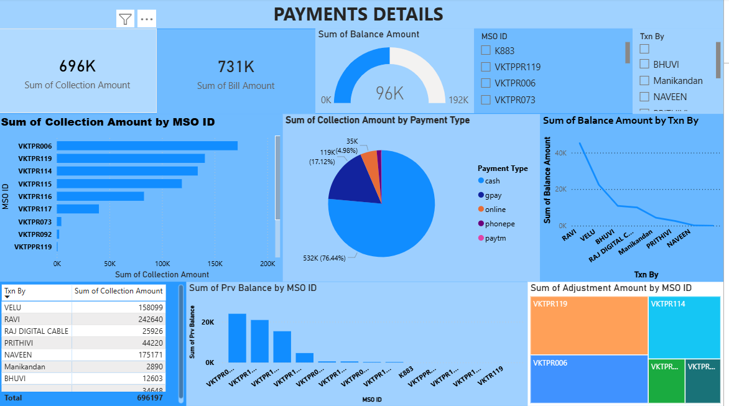

1. INTRODUCTION
In today’s digital era, organizations generate large volumes of transactional data. Analyzing this data manually is time-consuming and error-prone. Business Intelligence (BI) dashboards help in visualizing data clearly and tracking performance metrics in real-time.
This project aims to:
• Analyze payment collection data
• Track billing and outstanding balances
• Understand customer payment behavior
• Compare MSO-wise performance
• Provide easy-to-read visual reports
The dashboard serves as a financial monitoring system for cable network operations.

2. DATASET SUMMARY
The dataset titled "JANUARY 2026 PAID LIST" contains 2,465 records and 22 columns.
Key Fields in Dataset:
Column Name | Description
Customer Name | Name of subscriber
MSO ID | Operator identification
Prv Balance | Previous outstanding amount
Bill Amount | Monthly billing amount
Collection Amount | Amount collected
Adjustment Amount | Manual adjustments
Balance Amount | Remaining balance
Txn By | Collected by staff
Payment Type | Cash, GPay, Online, Paytm, PhonePe
Area | Customer location
Status | Payment status

📌 Overall Financial Summary:
Metric | Amount
Total Bill Amount | ₹731,154
Total Collection Amount | ₹696,197
Total Balance Amount | ₹95,802

3. KEY PERFORMANCE INDICATORS (KPI) EXPLANATION
✅ 1. Sum of Collection Amount
₹696,197
Represents the total revenue collected during January 2026.

✅ 2. Sum of Bill Amount
₹731,154
Total amount billed to all customers.

✅ 3. Sum of Balance Amount
₹95,802
Outstanding unpaid amount.
Helps identify pending payments.

✅ 4. Collection by MSO ID
Top performing MSOs:
MSO ID | Collection (₹)
VKTPR006 | 171,836
VKTPR119 | 140,672
VKTPR114 | 133,911
VKTPR115 | 118,807
VKTPR116 | 82,811
Shows which operators generate higher revenue.

✅ 5. Collection by Payment Type
Payment Type | Amount (₹) | Percentage
Cash | 532,188 | 76.44%
GPay | 119,191 | 17.12%
Online | 34,648 | 4.98%
PhonePe | 9,390 | 1.35%
Paytm | 780 | 0.11%
➡ Indicates customers prefer cash payments the most.

✅ 6. Balance by Transaction Person
Shows which staff members have higher pending balances in their transactions.
Useful for accountability and follow-up.

4. DASHBOARD DESCRIPTION
The dashboard includes:
📈 KPI Cards:
- Total Collection Amount
- Total Bill Amount
🎯 Gauge Chart:
- Total Balance Amount (Outstanding)
📊 Bar Chart:
- Collection by MSO ID
🥧 Pie Chart:
- Collection by Payment Type
📉 Line Chart:
- Balance Amount by Transaction Person
📋 Table:
- Collection amount by staff
🧱 Tree Map:
- Adjustment amount by MSO
🎛 Filters:
- MSO ID
- Transaction By
These filters allow dynamic data exploration.

5. METHODOLOGY
Step 1: Data Collection
Payment records were exported in Excel format.
Step 2: Data Cleaning
- Removed null values
- Verified numeric fields
- Standardized payment types
Step 3: Data Processing
- Summation of billing and collection
- Grouping by MSO ID and payment type
Step 4: Visualization
Charts and KPIs created using BI tools.
Step 5: Analysis
Identified revenue trends and outstanding balances.

6. RESULTS & INSIGHTS
✔ Total collection is close to total billing indicating good recovery rate
✔ Cash dominates payment methods (over 76%)
✔ Few MSOs contribute major portion of revenue
✔ Outstanding balance still exists and needs monitoring
✔ Digital payments are growing but still limited

7. ADVANTAGES OF THE SYSTEM
✅ Real-time financial monitoring
✅ Easy performance comparison
✅ Reduced manual calculations
✅ Improved decision making
✅ Transparency in collections

8. LIMITATIONS
⚠ Data limited to one month
⚠ Manual data entry errors possible
⚠ No predictive analysis

9. FUTURE SCOPE
🚀 Add multi-month trend analysis
🚀 Implement automated data upload
🚀 Include predictive revenue forecasting
🚀 Mobile-friendly dashboard
🚀 Alert system for high pending balances

10. CONCLUSION
This project successfully demonstrates how payment collection data can be transformed into meaningful business insights using dashboard visualization.
The system provides:
• Clear financial overview
• Identification of high-performing MSOs
• Understanding of customer payment behavior
• Efficient tracking of outstanding balances
Such BI solutions can greatly improve operational efficiency in service-based industries.

